Community College of Baltimore County Labor Studies Program
Workplace Rights Project
Does your boss call you a contractor?
Misclassification of Workers
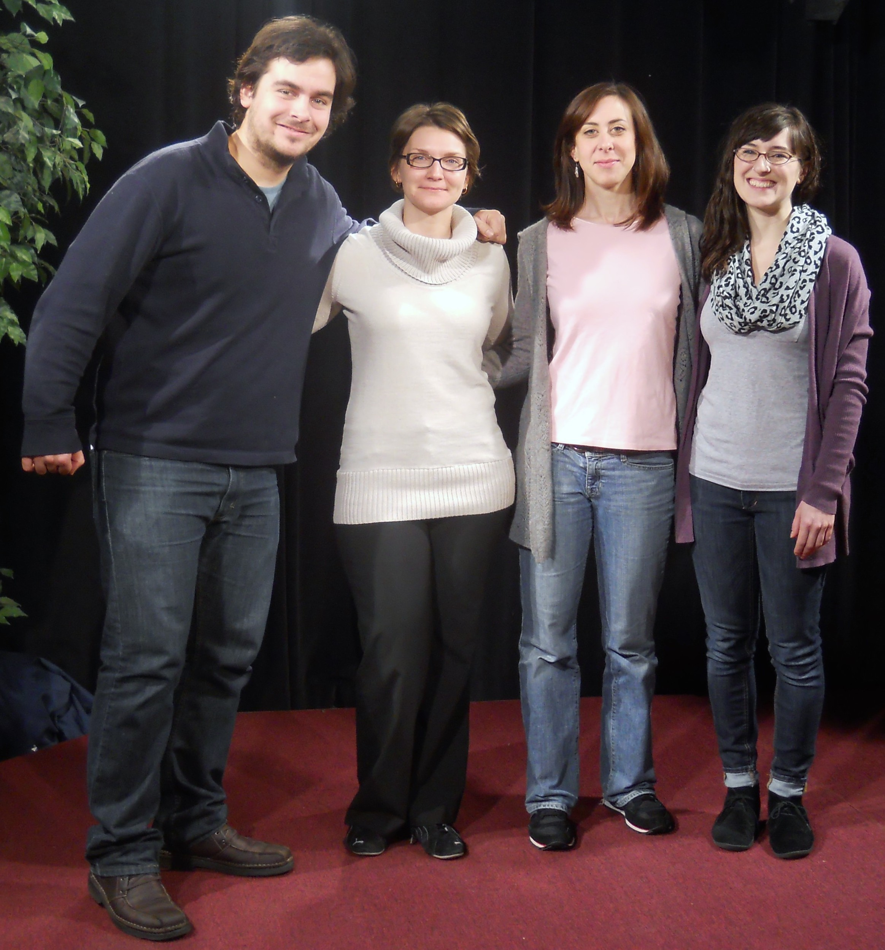

Lovel Tokic, Andrea Vaughn, Alexandra Rosenblatt and Rachel Boss
The Public Justice Center
1 North Charles Street, Suite 200
Baltimore, MD 21201
Telephone: (410) 625-9409 Fax: (410) 625-9423 1-877-3-JUST PAY
http://www.publicjustice.org/
VIDEO LINKS
To report workplace fraud in Maryland
http://dllr.state.md.us/workplace/

